SIMATS ENGINEERING (SAVEETHA SCHOOL OF ENGINEERING)
Department of Computer Science and Engineering
CO3 ASSESSMENT TOOL 1 — Git & Docker Technical Assignment
Course Code: | CSA1007 | Course Title: | Software Engineering
CO Assessed: | CO3 | Assessment: | Assessment Tool 1 – Git & Docker Technical Assignment
Weightage: | 20% | Total Marks: | 25
CO3 Statement: | Build full-stack applications with an emphasis on containerization, version control, and collaborative development.
Student Name: | M.DINESH KUMAR REDDY | Reg. No.: | 192372251
Date: | 08/08/2026 | Duration: | 60 minutes

Code of Conduct
I, MADITHATI DINESH KUMAR REDDY(192372251), certify that this submission is my original work and that I have adhered to the guidelines specified for this assessment. I understand that any violation of academic integrity rules will result in disciplinary action.
Signature of the Student: N. Madhusudhan

Smart Disaster Relief Coordination Platform

1. Problem Analysis
The assigned project is a Smart Disaster Relief Coordination Platform that coordinates disaster response by collecting incident information, monitoring affected areas, allocating relief resources, coordinating rescue teams, tracking shelters and victims, and sending real-time alerts. The core project objectives are to improve coordination among emergency teams, provide timely and accurate situational awareness, and ensure that relief resources reach affected people efficiently.
- Functional requirements: real-time disaster incident monitoring, emergency team coordination, AI/ML-based risk and priority analysis, relief-resource tracking, shelter and victim management, route and status tracking, and instant emergency notifications.
- Expected outcomes: faster disaster response, better resource allocation, improved communication among rescue teams, reduced response delays, enhanced public safety, and improved coordination during relief operations.
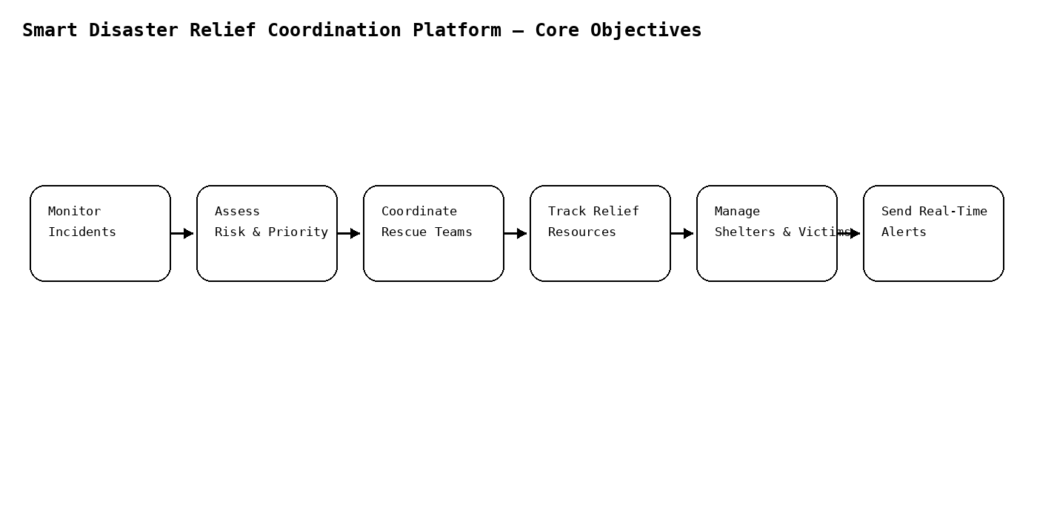
Figure 1: Core system objectives derived from the Smart Disaster Relief Coordination Platform problem statement

2. Project Structure Design
The repository is organized as a microservices monorepo, with one folder per disaster-relief capability plus shared infrastructure and documentation folders, so that each module can be built, tested, and containerized independently.
- Service folders (incident-management, rescue-coordination, resource-management, shelter-management, notification-service, dashboard-service): isolate each disaster-relief capability's code, tests, and Dockerfile.
- api-gateway/ and frontend/: house the single entry point and the Emergency Operations Center (EOC) web UI, kept separate from backend disaster-relief logic.
- infra/: centralizes docker-compose.yml and reverse-proxy configuration so orchestration is not scattered across services.
- .github/workflows/, docs/, .gitignore, README.md: support CI automation, architecture documentation, clean version control, and onboarding for emergency-response teams.
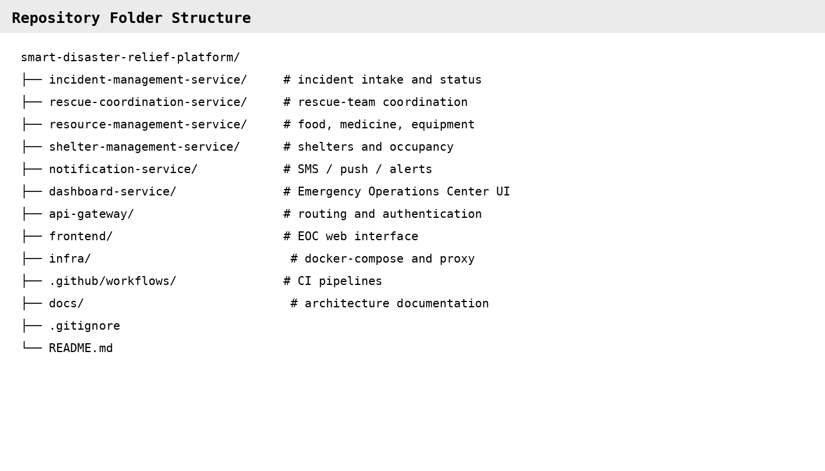
Figure 2: Repository folder structure for the Smart Disaster Relief Coordination Platform.

3. Git Repository Initialization
The repository was initialized with git init, followed by creating a README.md and a .gitignore before the first commit, so that history begins from a clean, documented baseline. The repository was then linked to a remote and pushed to establish the shared origin for the disaster-relief engineering team.
- .git/ — hidden metadata directory Git uses to track history, branches, and configuration; created automatically by git init.
- .gitignore — excludes build artifacts, node_modules, .env secrets, and other machine-specific files from version control.
- README.md — documents the platform purpose, setup, architecture, and structure for new contributors.
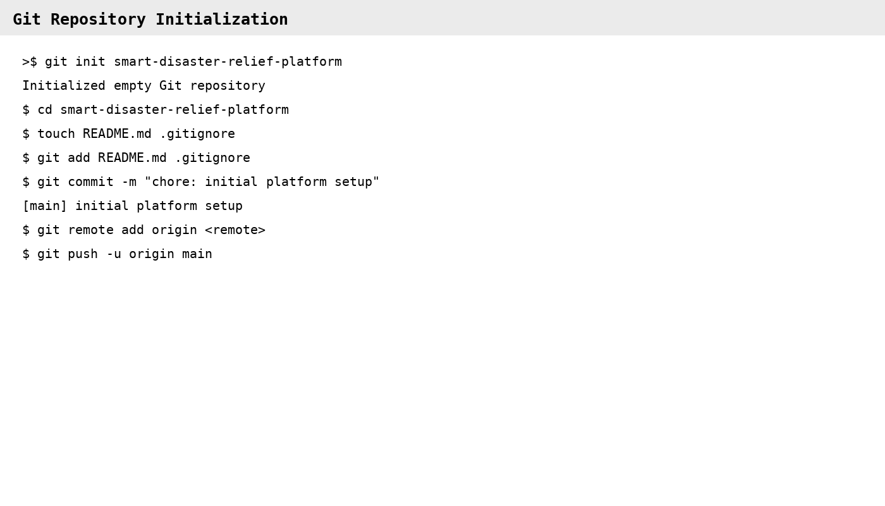
Figure 3: Git repository initialization sequence for the disaster-relief platform.

4. Git Branching Strategy
A Git-Flow-inspired strategy was adopted: a stable main branch, an integration develop branch, short-lived feature/* branches per disaster-relief capability, release/* branches for stabilization, and hotfix/* branches for urgent production fixes.
- main only ever holds production-ready, tagged releases, keeping deployment risk low for a time-critical disaster-response platform.
- develop integrates completed features before a release is cut, giving a stable point for cross-service integration testing.
- feature/* branches (e.g., feature/incident-management-service) isolate each microservice's work, matching the project's modular architecture and letting multiple emergency-response engineering teams work in parallel without blocking each other.
- hotfix/* branches patch main directly and back-merge into develop, so urgent fixes to incident, rescue, or notification services reach production fast without waiting for the next release.
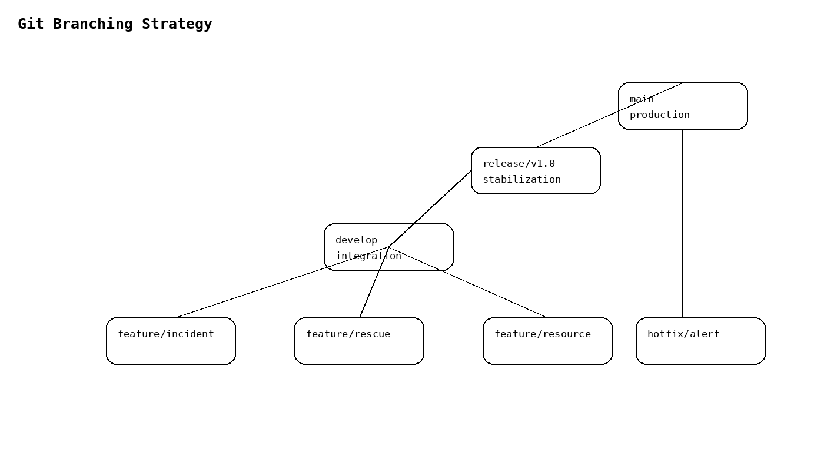
Figure 4: Git branching strategy for the Smart Disaster Relief Coordination Platform.

5. Version Control Workflow
The workflow below demonstrates a complete cycle: branching off develop, committing meaningful changes, merging back with conflict resolution, and synchronizing with the remote repository.
- git checkout -b creates an isolated branch so in-progress work never destabilizes develop.
- git commit with a scoped message records an atomic, traceable change to the incident management service.
- git merge --no-ff preserves branch history; a conflict in incident_service.py can be resolved manually and re-committed, demonstrating safe conflict handling.
- git pull --rebase and git push keep the local and remote develop branches synchronized without creating unnecessary merge commits.
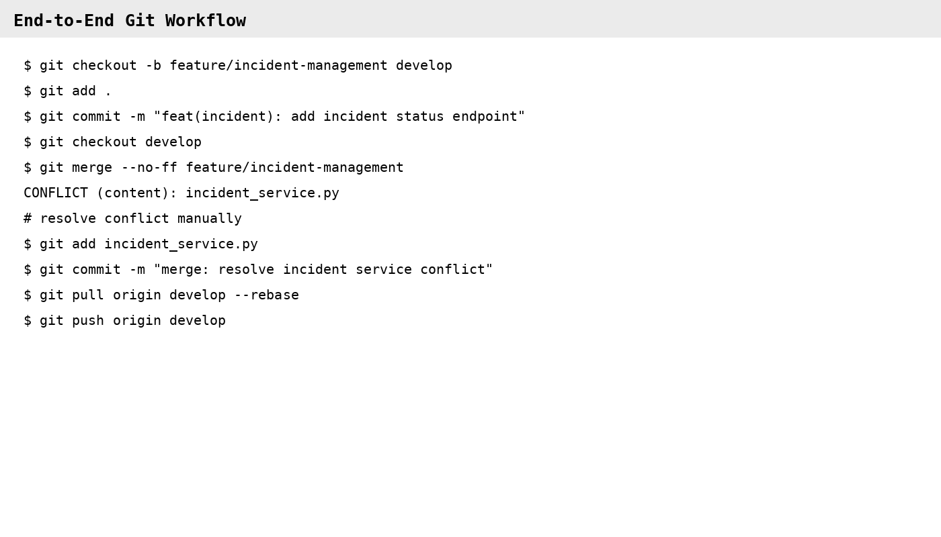
Figure 5: End-to-end Git workflow — branch, commit, merge, conflict resolution, and synchronization.

6. Commit History Analysis
The commit graph below shows a linear main history feeding into develop, with a feature branch merged back through an explicit merge commit. Every message follows the Conventional Commits format, <type>(<scope>): <description>, which keeps history searchable and self-documenting.
- Consistent types (feat, fix, chore, merge) let the team filter history by change category during release notes generation.
- Scoped messages (e.g., incident, rescue, resource, gateway) trace each commit directly to the affected disaster-relief module, simplifying debugging and audit review.
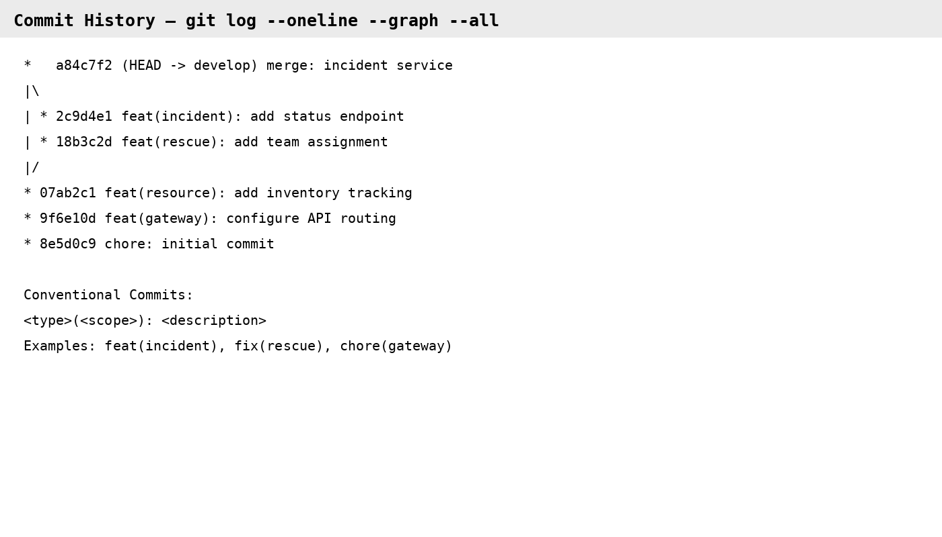
Figure 6: Commit history (git log --oneline --graph --all) for the disaster-relief platform.

7. Docker Environment Design
Docker is well suited to this project because the platform is composed of independently deployable microservices, including incident processing, rescue coordination, resource tracking, and notification services, that must run consistently across developer machines, CI, and production while remaining reliable during high-demand disaster events.
- Containerization eliminates environment drift between developers and deployment targets.
- Each service scales independently, such as adding extra incident-processing or notification replicas during a major emergency, without over-provisioning lighter services.
- Components requiring containerization: the six backend microservices, the API gateway, the Emergency Operations Center frontend, and supporting infrastructure such as PostgreSQL, Redis, and Kafka.
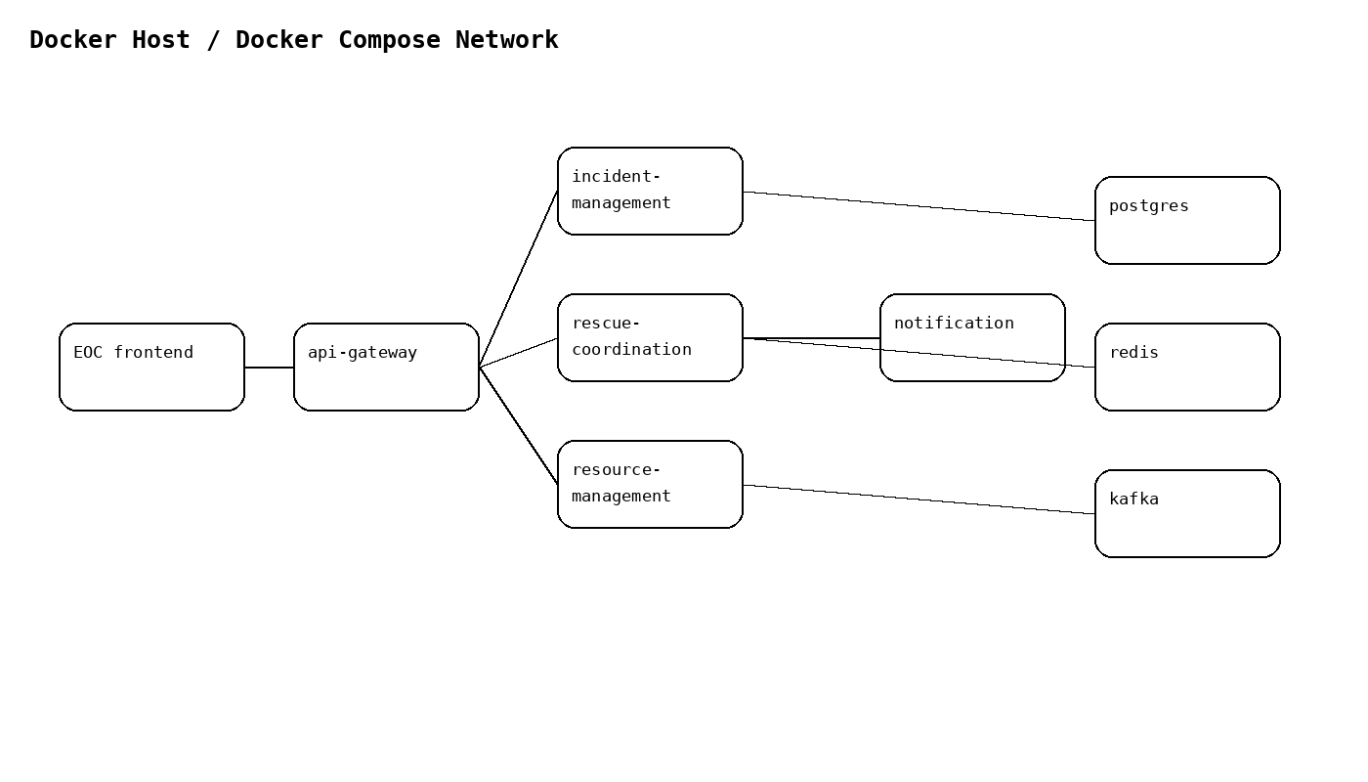
Figure 7: Components requiring containerization and their interactions.

8. Dockerfile Development
The Dockerfile below containerizes the incident-management service using a slim Python base image, installs dependencies before copying source code to maximize layer-cache reuse, runs as a non-root user for security, and defines a health check so the orchestrator can detect failures.
- FROM selects a minimal, version-pinned base image to reduce attack surface and image size.
- WORKDIR / COPY / RUN order is chosen deliberately so dependency installation is cached separately from source code changes.
- USER appuser drops root privileges inside the container, following container security best practice for a critical emergency-response platform.
- HEALTHCHECK and CMD define how the container reports readiness and how it starts the application server.
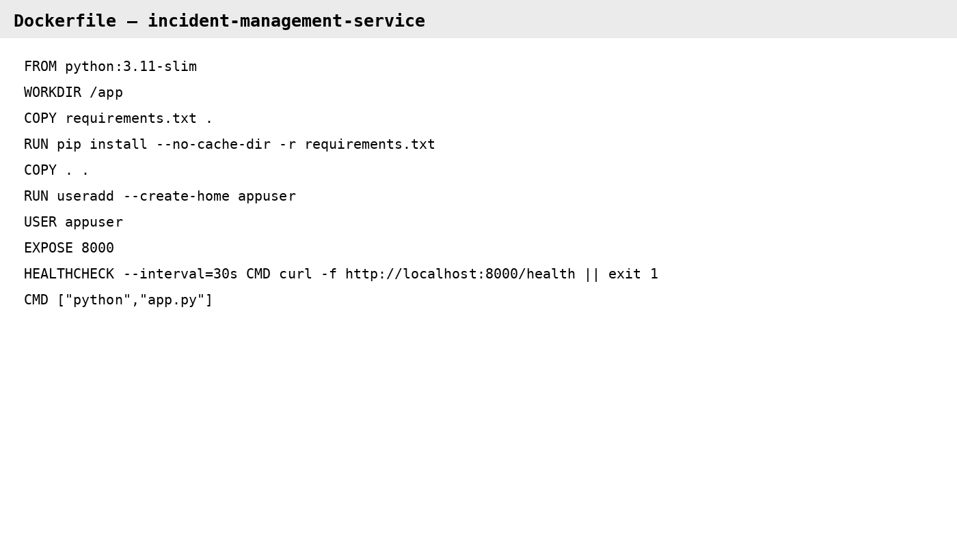
Figure 8: Dockerfile for the incident-management-service.

9. Docker Compose Design
Docker Compose orchestrates all services on a shared bridge network so containers can reach each other by service name, while only the gateway and frontend expose ports to the host.
- Services: gateway, incident-management, rescue-coordination, postgres, redis, and kafka, each built or pulled independently.
- Networking: a single backend bridge network isolates inter-service traffic from the host network, exposed only through the gateway.
- Volumes: a named pgdata volume persists incident, resource, shelter, and audit data across container restarts.
- Environment variables: DB_URL is injected at runtime with secrets externalized, keeping credentials out of the image.
- Dependencies: depends_on ensures postgres, redis, and kafka start before the services that require them.
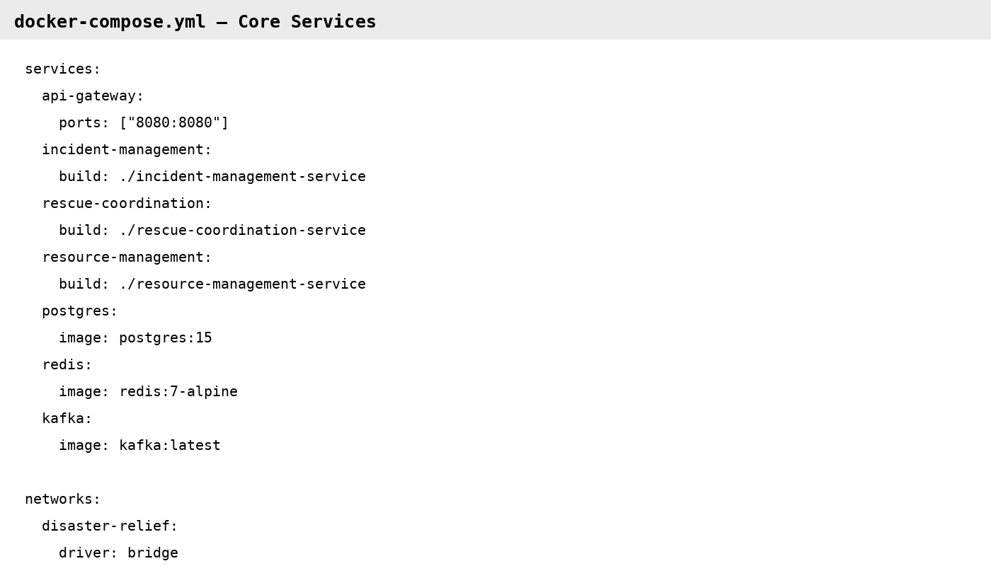
Figure 9: docker-compose.yml configuration for the disaster-relief platform.

10. Container Deployment and Testing
Running docker-compose up --build -d builds and starts every container in dependency order. docker ps confirms each container reports a healthy status, and a functional test through the API gateway confirms that the incident-management service is reachable end-to-end and returning a valid response.
- Deployment evidence: all containers reach 'healthy' status within the expected startup window.
- Testing procedure: a curl request through the API gateway to the incident-management service validates routing, service health, and response correctness in one step.
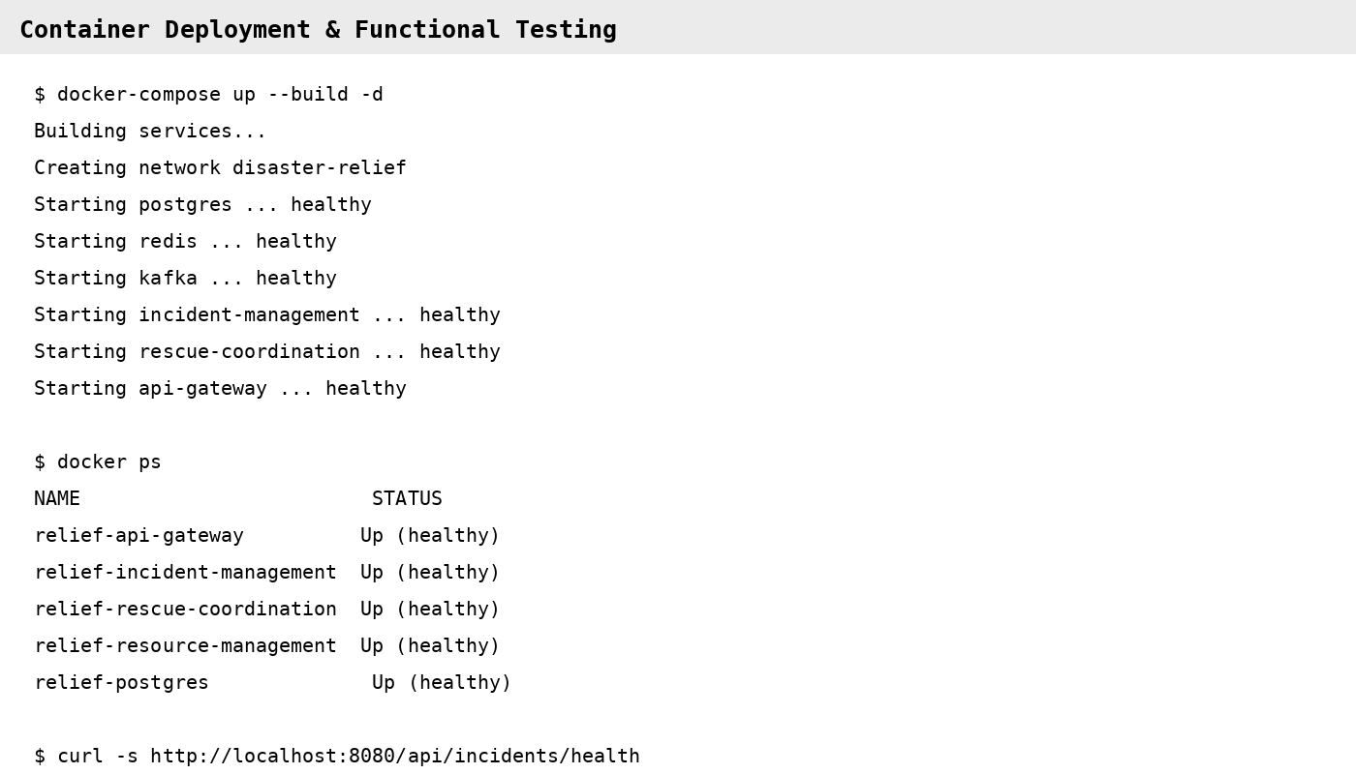

11. Benefits of Git and Docker
Together, Git and Docker directly address the collaboration and operational challenges of a multi-service, time-critical disaster-relief platform, summarized below.
Dimension | Benefit from Git | Benefit from Docker
Collaboration | Parallel feature branches let incident, rescue, and resource teams work simultaneously without blocking each other. | Identical local dev containers eliminate 'works on my machine' issues across the team.
Version Management | Full history and tags (v1.0, v1.1) enable safe rollback of platform services. | Image tags version the exact runtime environment alongside the code.
Portability | Repository clones identically on any developer machine or CI runner. | Containers run identically on a laptop, CI runner, or cloud provider.
Deployment | Protected main branch + PR review gates what reaches the disaster-response environment. | docker-compose up / CI pipeline gives fast, repeatable, one-command deployment.
Scalability | Feature branches isolate work so new relief-coordination modules can be added without disrupting others. | Each microservice container can be scaled independently during large-scale emergencies.
Maintainability | Commit history and blame trace exactly when and why a platform change was made. | Dockerfiles document the runtime setup, removing manual server configuration drift.

12. Challenges and Improvements
Implementation surfaced several practical challenges, each with a corresponding improvement identified for future iterations of the Git workflow and Docker deployment.
Challenge Encountered | Suggested Improvement / Future Enhancement
Merge conflicts when multiple feature branches touched shared incident or resource-management code. | Adopt smaller, more frequent PRs and enforce code-owner review on shared modules.
Large Docker image sizes slowed down build and deployment time. | Use multi-stage builds and slim/alpine base images to reduce final image size.
Managing environment-specific secrets such as database passwords and API keys. | Introduce a secrets manager such as Docker Secrets or Vault instead of plain .env files.
Coordinating release timing across multiple disaster-relief microservices. | Add automated CI/CD pipelines with staged rollouts and semantic-version release tagging.

